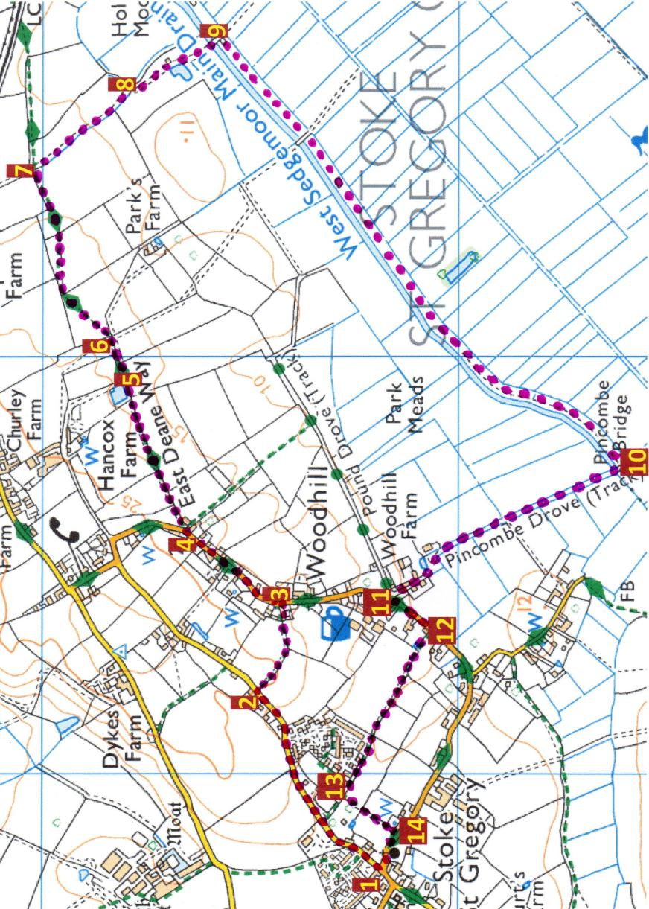

**Dark Lane, Woodhill, East Deane Way, Main Drain, Pincombe Drove**

Updated March 2023

**Walk 8 *5.7kms 3.5mls***

Keep straight on and you will get to a gate and stile alongside it which takes you into Pincombe Drove **10**. Turn **R** - the drove can get very rutty and muddy so wellies advisable. Keep straight on and the drove does become tarmacced between a few houses / barn conversions. You are nearly back on Woodhill and when you get there **11** turn **L** until you reach Larkfield Cottage on your **R 12**. Just past this is a Bristol gate and turn **R** through this and you soon reach a field. Go straight across towards some houses and then through a kissing gate and keep straight with the houses on your **R** then a grassy area also on your **R** till you get to a stile on your **L 13**. Climb over this and go straight towards the church. Walk through the gate **14** and turn **R** and you are very nearly back to the shop and pub.

Alternatively, at **9** you could continue on the drove till you get to North Drove and turn **R** and keep going till you get to the bottom of Pincombe and turn **R** again and keep going. There are rhynes on both sides of North Drove most of the way so likely to see ducks and swans there as well and herons, lapwing in the winter and possibly cranes and other wildlife.

Starting with your back to the community shop and Royal Oak pub **1** turn **L** and walk up Dark Lane past the village hall on your **L** and the turning to Polkesfield a bit further on on your **R**. About 100m further, a bungalow, Pyms Orchard is on your **L** and steps up into a field on your **R** **2**. Go up these steps and and a short slope then keep along the hedge on your **R**. Walk across the field to a stile. Go over this and between a few houses out on to Woodhill **3**. Turn **L** and keep going till you reach Ivy Villa Farm on your **R**. There are two stiles by the house **4**. Go over the **L** one that goes straight on (high first step) and keep the field hedge on your **R** and over a stile into the next field, again keeping the hedge on your **R** and then a squeeze stile into a third field with lovely views over to your **R** - Sedgemoor. Go through a second squeeze stile into a narrow track with the field on your **L** several feet higher and hedge on the **R**. Go through a third squeeze stile, keep straight across the track **5** into another field keeping the hedge on your **R**. Then through a pedestrian gate and over a bridge and another pedestrian gate Continue along the hedge through a pedestrian gate and over a narrow bridge. **6** The path then goes diagonally across the field to the far corner. Again there are beautiful views. There is another pedestrian gate. Go through this and go across the field alongside the hedge on your **L** and you reach a bridge and pedestrian gate and go straight ahead with hedge on your **L** and keep round to the **R** and then **L** till you reach a Bristol gate. Go into a drove **7** and turn **R** - the East Deane Way goes straight on. This drove is not a right of way but the owner has kindly given permission for it to be walked. There is a sharp bend to the **R** and then **L 8**. There is a ruined building on your **L** which is marked as Hunts Dairy on the old maps. There is a bridge over the main drain and a gate. **9** Go through this and turn **R** and walk alongside the drain to another gate which is sometimes tied shut but is fairly easily opened. There is another bridge on your **R** which you ignore walking straight on past a small clump of trees. Burton Pynsent Monument is on the crest of the hill on your **L** across the other side of Sedgemoor. There are often swans, little egrets and herons to be seen on the drain and, at the right time of year swans nesting then cygnets. Ducks and ducklings tend to stick to the rhynes where there is more shelter.